Institute of Grace December 2017 Newsletter

Merry Christmas and Happy New Year from the Institute of Grace.
2017 has been a year of many accomplishments and continued progress. The IOG has several primary projects: The EGF School, The Universite de la Grace, The Miracia Medical Center, and working with church leaders in the Merger area. Here are some of the highlights from 2017:
The Ecole Gerny Filostin School now has a range of classes from 3-year-old kindergarten to 7th grade. Enrollment has increased to over 180 students as we added 7th grade and additional classroom space allowed individual classes for 3rd, 4th, 5th and 6th grades. Madam Rosalyn continues to lead this effort very effectively. Payroll and feeding costs have increased significantly so we continue to pray for increases in regular support for teacher salaries and kitchen costs.
It may not look like much, but what a difference it makes for 180+ children.
The Universite de la Grace has completed its first year in new classrooms in Merger after a multiyear hiatus following the damage to the Delmas facility following the 2010 earthquake. We are working with a new school director and supporting staff so that Jean Filostin will no longer need to run that operation. The school is now located on the ground floor of the Guest House in Merger.
Miracia Hospital is closer to being operational as the new larger cistern has been completed and a ramp has been built to the 3rd floor of the building. Iron bars have been added to the 3rd floor windows for increased security and the outside of the building has been ‘polished’ so that it is ready for painting. The clinic has been operating with just a nurse throughout the year in support of the school. And a team of doctors is putting together a plan to increase the medical presence in Merger. Please see Jean’s appeal at the end of this newsletter.

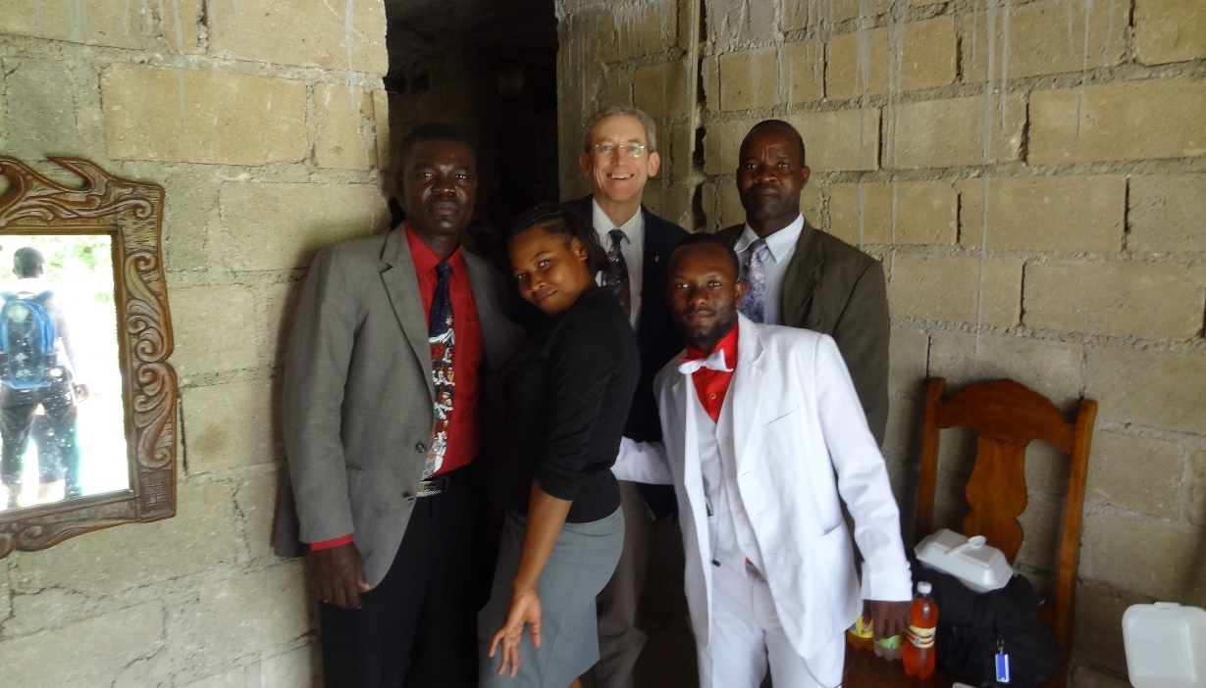
Pastor David with four of the university students after church.
We have held 20 days of church leadership and theology classes spread across five different teams this year with support from several churches and pastors. And we have worshiped with several churches in the community, as this in an ecumenical project reaching across denominational lines.
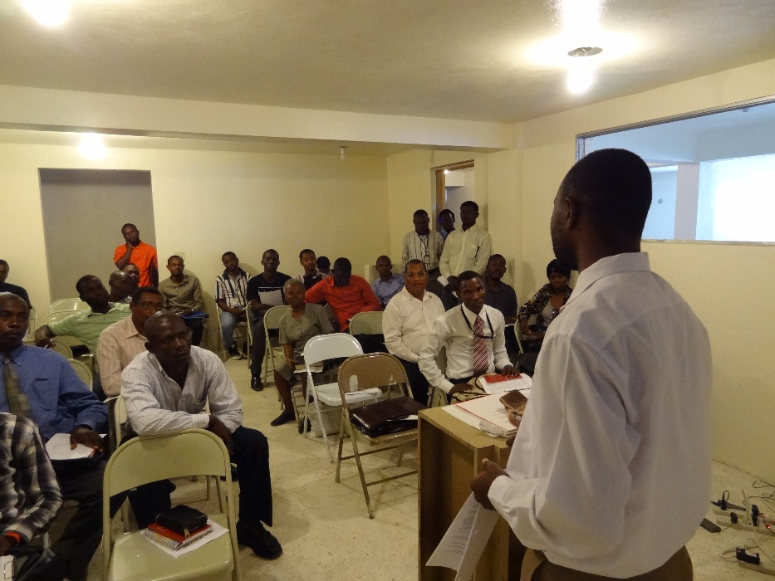
Student Advisor Pastor Amorse speaking with the Universite students.
In all, the IOG hosted six teams in 2017 and Executive Director Jean Filostin spent over 22 weeks in Haiti directing many projects. The second floor of the Guest House has been prepared so we now have 10 bedrooms and 8 bathrooms ready for teams to enjoy. We are now scheduling teams for 2018. The people in Haiti are so encouraged by your visits and support.
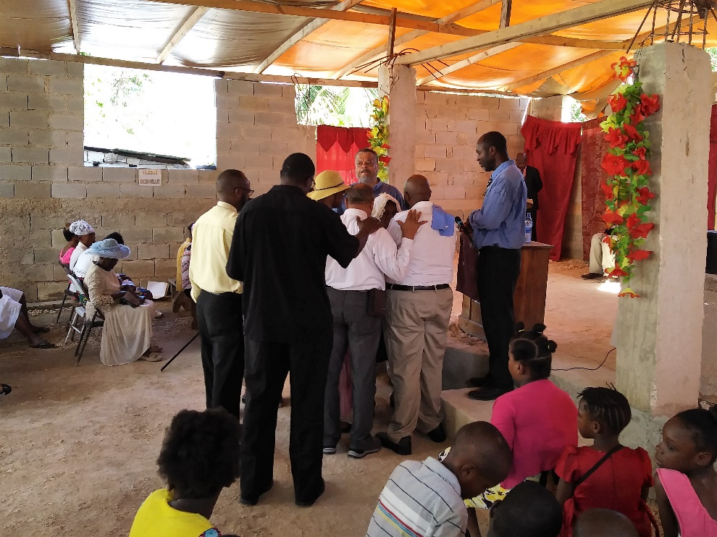
The June Church of the Redeemer team at worship.
I’ve got more pictures than will fit in an email, so I invite you to follow this link for 14 more pictures of the people and facilities in Haiti: https://1drv.ms/w/s!AmmGvovNRcD6grgcn59sOxAjKqBjhQ
As always, we ask you to hold these efforts in prayer and realize that this work would not be possible without the continued support of our U.S. partners. $200 a month will support an entire classroom of students, many of whom would be roaming the streets with your help. $10 will feed a student for an entire month.
Every contribution makes a difference for these people. Thanks for your prayers and support!
David Graves
Director of US Operations, Institute of Grace
240 601 0218 davidgraves1982@gmail.com

Contributions can be sent to:
Institute of Grace
P.O. Box 2364
Leesburg, VA 20177

contact David Graves for information about setting up a direct contribution.
The IOG employs Haitians in the local communities, and has opportunities for missionaries to work in country. Without contributions from the United States, the school and university would not be able to reach so many students, so funding is a critical component of this ministry.

Please continue to the next page for a letter from Jean Filostin.

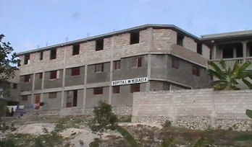 | MH Hôpital de Miracia  Première Entré St Antoine, Rue Miracia # 20  K-Paix Merger, Haïti  Téléphone:509-3164-6868 ; 3604-5659 / 509-3873-7314, Email : iograce2001@gmail.com
I would like to thank all of you who have contributed to the Miracia Hospital Project in Haiti. A special thanks to all those who contributed funds to complete the water cistern and the ramp over the past two years. With the help of God Almighty and your contributions the cistern is now covered and the ramp to the third floor has been built above it.
At this time, the challenge for us is to inaugurate Miracia in January 2018. I need to raise $40,000 as startup fund. The Lord God Almighty has been gracious to us in the past; therefore, He will continue to grant us favor to make the inauguration possible. Please, help us with your donation to raise $40,000.
Below, is an explanation of $40,000 we are seeking. Thank you for your monetary participation in this fund-raising effort.
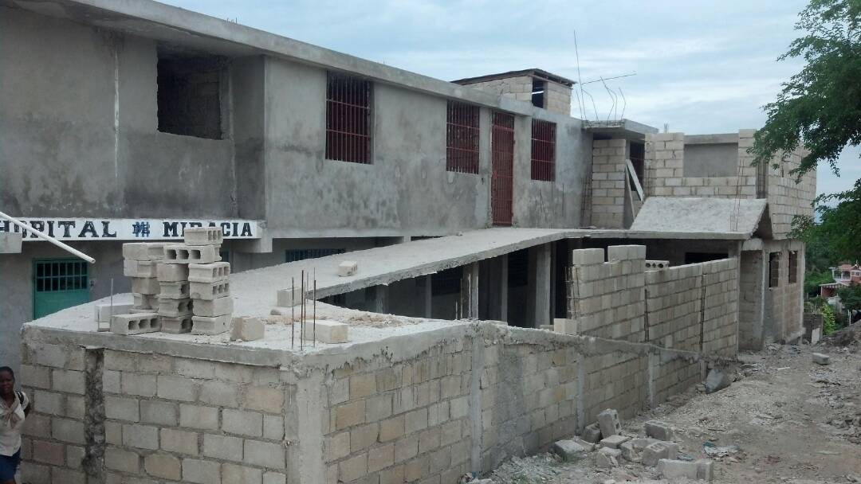
The ramp over the cistern to the third floor. floor.
Jean Filostin

Executive Director, Institute of Grace
1221 Van Buren St., NW #202A
Washington, D.C. 20012
Phone: 301.254.5431
Email: iograce2001@gmail.com

jEAN
TABLE OF NEEDS
ITEM | # OF ITEMS | UNIT COST | TOTAL COST
SIGNS (Concrete) | 6 | $500 | $3,000
MASONRY WORK |  |  | $5,000
PAINT | 20 5-gal buckets | $100 | $2,000
SUPPLIES |  |  | $10,000
STAFF SALARIES | 3 months for start up | $5,000/month | $15,000
MEDICINES |  |  | $5,000

